Relationship with God

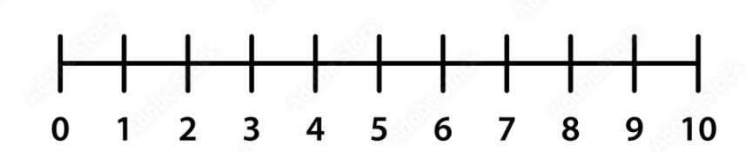

Don’t have one

Great

God and I speak Daily

Getting better daily

Working on it

Needs

Work

Relationship with Family



Bad

Needs Work

Could be better

Getting better

Good

Great

Confusion



I’m happy,

No confusion

Mostly Happy

I’m always confused

Confused most of the time

Even Split